**New in the HR/Pay update on 10/20/2024:**

1. Manage Absences tile replaces the Request Absence tile.
2. Timesheet now has Payable Time, Exceptions, and Absence Balances at the bottom of the page.
3. Absences paid will load to payable time the day after the absence is approved for current or past pay periods.

**1. Manage Absences tile replaces Request Absence**

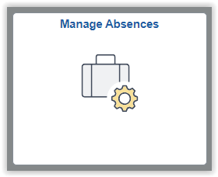

Use the Manage Absences tile to request absences, view your balances, display the last three absences requested, and have a link to View Requests all on one page. There is also a holiday listing for those employees eligible for holidays.

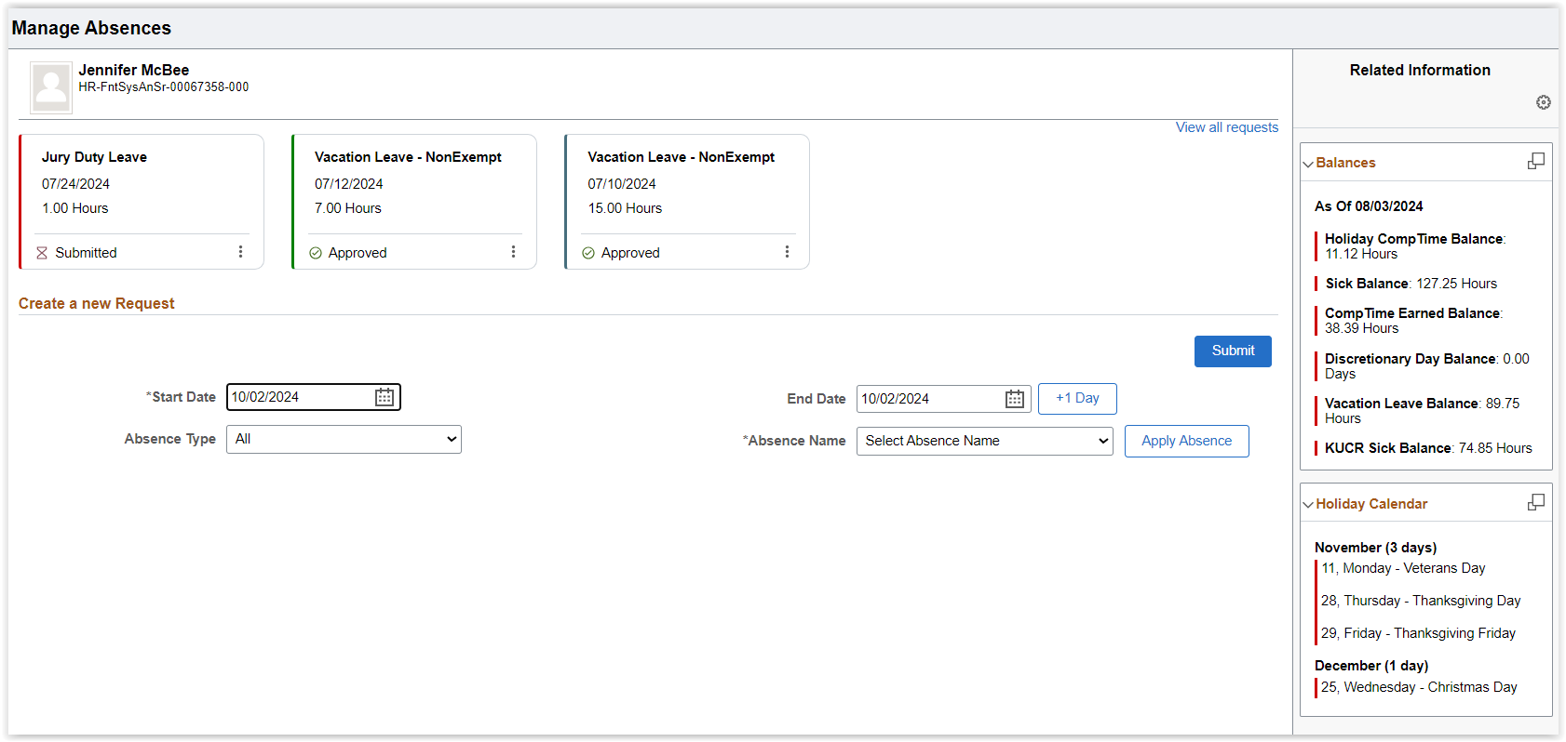



When requesting an absence, select the Dates first.

* *Note: The Start and End Dates default to today’s date. Be sure to update both dates as needed.*

After selecting the Dates, Absence Type, and Absence Name, you will need to **click the Apply Absence button**.

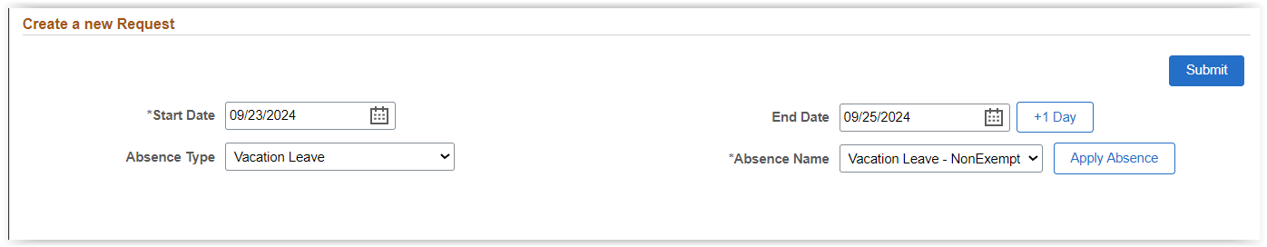

Only then will the detailed options for that absence name appear:

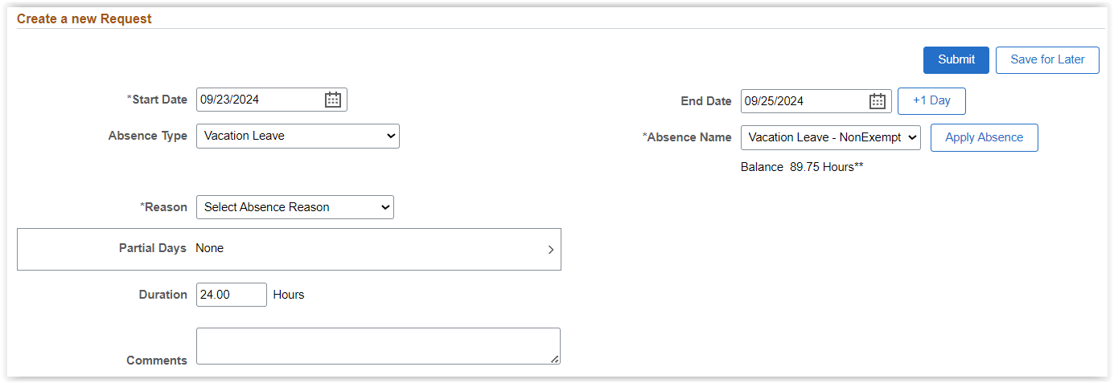

Then proceed to select the Reason, change Partial Days if needed, add any Comments if needed, and click Submit.

Note: If you change the Absence Type or Absence Name, you will need to select the Apply Absence button again.

**2. Timesheet has more information at the bottom of the page**

New in the timesheet, at the bottom of the page:

* Time Summary – shows deviation from scheduled hours (only for timesheet users).
* Absences – shows absence balances as of most recent pay period end date.
* Exceptions – shows any timesheet exceptions for the person.
* Payable Time – shows payable time generated by Time Admin (a process ran twice a day-morning and evening) based on time reported in the timesheet. It also shows the status of the payable time (Needs Approval, Approved, Taken by Payroll) (displayed below).

