**Team Time & Absence – Fixing an Exception**

Database: <https://hr.ku.edu>

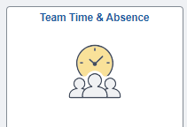

Select the Team Time & Absence tile

**Timesheet – Enter Time**

1. Select the employee’s name from the list. ***Select Employee*** allows moving between employees.

You can also select the filter to find a specific name.

**\***The red clock icon indicates an exception exists.

1. At the top left, use the date box to select the date that needs edited or you can use the arrows to move between weeks.

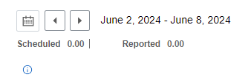

1. Enter the missed punch in the appropriate “in” or “out” box .

1. The **+** and **–** at the end of the row are for adding or deleting rows.
2. Please add a comment in the bubble or cut and paste the email from the employee, to provide audit documentation.

1. Select the blue Submit button, top right.

